Name (in Romaji):
Student Number:
Class Day + Period
(examples: Monday 2, Friday 3):

TP Chapter 05 Quiz

Chapter 5.1
Activity 1: Identifying Stress Levels

In Chapter 5, you learned that there are three levels of stress in English sentences: strong stress, normal stress, and unstress.

Predict
Before you listen, read the sentences and try to predict which words will get normal stress and which will be the focus word. Also, predict which words will be unstressed.

1. I went to the bookstore on Monday.
Which words get normal stress?
a. went
b. bookstore
c. Monday
d. Both a and b
e. Both a and c Answer

2. I went to the bookstore on Monday.
Which word is the focus word?
a. went
b. bookstore
c. Monday
d. Both a and b
e. Both a and c Answer

3. I went to the bookstore on Monday.
List one word that is unstressed.
a. I
b. to
c. the
d. on
e. Any of these Answer

4. Peter broke his watch.
Which word is the focus word?
a. Peter
b. watch
c. broke
d. Both a and b
e. Both a and c Answer

5. Peter broke his watch.
Which word is unstressed?
a. Peter
b. broke
c. his
d. watch
e. None of the above Answer

6. Peter broke his watch.
Which words get normal stress?
a. Peter
b. his
c. broke
d. Both a and b
e. Both a and c Answer

7. The baby is hungry.
Which word is the focus word?
a. hungry
b. baby
c. is
d. All of the above
e. None of the above Answer

8. The baby is hungry.
Which words get normal stress?
a. The
b. hungry
c. baby
d. Both b and c
e. Both a and c Answer

9. The baby is hungry.
Which words are unstressed?
a. The
b. baby
c. is
d. Both a and c
e. Both b and c Answer

10. Class ends in five minutes.
Which word is the focus word?
a. Class
b. ends
c. in
d. five
e. minutes Answer

11. Class ends in five minutes.
Which words get normal stress?
a. class
b. ends
c. five
d. All of the above
e. None of the above Answer

12. Class ends in five minutes.
Which word is unstressed?
a. class
b. ends
c. in
d. five
e. minutes Answer

13. Yesterday we went shopping.
Which word is the focus word?
a. yesterday
b. we
c. went
d. shopping
e. None of the above Answer

14. Yesterday we went shopping.
Which words get normal stress?
a. yesterday
b. went
c. shopping
d. Both a and b
e. Both a and c Answer

15. Yesterday we went shopping.
Which word is unstressed?
a. we
b. went
c. shopping
d. Both a and c
e. None of the above Answer

Listen
Listen to the audio clip while looking at the answers you selected above. Correct any mistakes you think you made.

<><><><><><><><><><><><><><><><><><><><><><><><><><><><><><>

Chapter 5.2
Listen
Select which word or words are stressed in each sentence.

1. Cats chase mice.
a. cats
b. chase
c. mice
d. all of the above
e. none of the above Answer

2. The cats chase the mice.
a. The, cats
b. chase, mice
c. cats, chase, mice
d. all of the above
e. none of the above Answer

3. The cats will chase the mice.
a. The, cats
b. cats, will
c. cats, will, chase
d. cats, chase, mice
e. cats, chase, the, mice Answer

4. The cats will have chased the mice.
a. cats
b. cats, chased, mice
c. cats, will have
d. cats, have, chased
e. cats, have, mice Answer

Repeat
Listen again, but this time, repeat after the speaker. Keep clapping your hands with the beat.

Chapter 5.3
Activity 3: Stress Pattern Recognition

In Chapter 5, you saw elephants and mice used to represent stressed and unstressed words. In this activity, listen to the sentence and then try to figure out which pattern of elephants and mice fits the stress pattern of the sentences.

Predict
Before listening, try to predict the correct answers.

Listen
Listen to the sentences while looking at the answers you chose. Correct any mistakes you think you made.

1.
a. Pattern A:  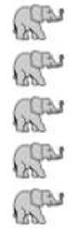 | b. Pattern B:  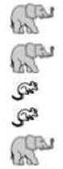 | c. Pattern C:  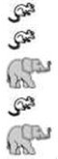
d. Pattern D:  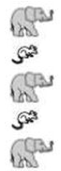 | e. Pattern E:  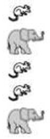

2.
a. Pattern A: | b. Pattern B: | c. Pattern C:  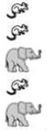
d. Pattern D: | e. Pattern E:  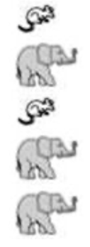

3.
a. Pattern A: | b. Pattern B:  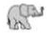  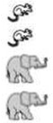 | c. Pattern C:
d. Pattern D: | e. Pattern E:

4.
a. Pattern A: | b. Pattern B:  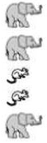 | c. Pattern C:
d. Pattern D: | e. Pattern E:

5.
a. Pattern A: | b. Pattern B: | c. Pattern C:
d. Pattern D: | e. Pattern E:

